MINISTRY OF EDUCATION AND TRAINING
FPT UNIVERSITY

INTEGRATING SPEECH-TO-TEXT AND
RVC-BASED VOICE CONVERSION
INTO AN AI ASSISTANT

By

Nguyen Hoang Ngoc Bao-24MSE23204

A thesis submitted in conformity with the requirements
for the degree of Master of Software Engineering

© Copyright by Nguyen Hoang Ngoc Bao 2026

MINISTRY OF EDUCATION AND TRAINING
FPT UNIVERSITY

INTEGRATING SPEECH-TO-TEXT AND
RVC-BASED VOICE CONVERSION
INTO AN AI ASSISTANT

By

Nguyen Hoang Ngoc Bao-24MSE23204

A thesis submitted in conformity with the requirements
for the degree of Master of Software Engineering

Supervisor:
1. Dr.Nguyen Xuan Sam

© Copyright by Nguyen Hoang Ngoc Bao 2026

INTEGRATING SPEECH-TO-TEXT AND
RVC-BASED VOICE CONVERSION
INTO AN AI ASSISTANT

Nguyen Hoang Ngoc Bao
Degree Master of Software Engineering
FPT University
2026

Abstract
This thesis proposes the integration of speech-based interaction into an existing Retrieval-Augmented Generation (RAG) legal assistant for Vietnamese enterprise law. While the current system effectively retrieves and generates answers using a vector database, embedding, and a large language model, it is limited to text-based interaction, which reduces usability and accessibility. To address this limitation, the study introduces a bidirectional voice interface by incorporating Automatic Speech Recognition (ASR) and Retrieval-based Voice Conversion (RVC). The proposed system utilizes Whisper for speech-to-text, Edge-TTS for base speech synthesis, and an RVC model trained on Google Colab to generate personalized voice output. The integration is designed to be modular and does not modify the existing RAG pipeline. The system is evaluated using both objective metrics, including latency and word error rate, and subjective measures such as Mean Opinion Score for naturalness and speaker similarity. Results are expected to demonstrate improved usability and more natural human-computer interaction.

Table of Contents

Table of Contents 4
List of Tables 6
List of Figures 7
1. Introduction and Background 8
1.1 Problem Description 8
1.2 Research Objectives 9
1.3 Scope of the Project 10
2. Literature Review 10
2.1 Automatic Speech Recognition (ASR) 10
2.2 Large Language Model (LLM) in the Pipeline 10
2.3 Personalised Voice Generation 11
2.4 Comparison of Voice-Generation Approaches 11
2.5 Why this Combination 11
3. Proposed Solution 12
3.1 Solution Description 12
3.2 High-level Pipeline 12
3.3 Software Architecture 13
3.3 Technology and Tools 14
4. Implementation Plan 14
4.1 Main Development Stages 14
4.2 Expected Schedule (12 weeks) 15
4.3 Feasibility Assessment 15
5. Expected Results 15
6. Evaluation Plan 16
6.1 Per-component Metrics and Acceptance Criteria 16
6.2 Metric Definitions and Threshold Rationale 16
6.2.1 Word Error Rate (WER). 16
6.2.2 End-to-end Latency. 16
6.2.3 Signal-to-Noise Ratio (SNR). 17
6.2.4 Mean Opinion Score (MOS). 17
6.3 Methods Used to Reduce Latency (RQ3) 17
7. Expected Results 18
8. References 18

List of Tables
Table 1 : Estimated comparison of typing and voice dictation 8
Table 2 . Comparison of voice generation approaches. 11
Table 3 : Technology stack of the integrated system. 14
Table 4 : Per-layer evaluation criteria with thresholds. 16

List of Figures
Figure 1 : High-level abstract pipeline of the Legal Voice Assistant. 13
Figure 2 : Software architecture of the Legal Voice Assistant. 14
Figure 3 : 12-week Gantt chart of the integration project. 15

1. Introduction and Background

1.1 Problem Description
With the recent advances in Large Language Models (LLM) and Retrieval-Augmented Generation (RAG) have made it practical to build domain specific assistants that read internal documents and answer user questions in natural language. As part of preliminary work for this thesis, I have implemented a working RAG-based legal assistant for Vietnamese enterprise law. The system uses a ChromaDB vector store, BGE embedding, and a Llama 3.1 language model served through the Groq API, exposed via a Flask web application with user authentication and persistent chat history (Figure 1). The values in Table 1 are estimated based on commonly reported average typing speeds (~40 wpm) and speech rates (~120–150 wpm) in prior literature.
Task | Typing  (40 wpm) | Dictation  (120 wpm) | Time Saved
500-word email | 12.5 minutes | 4 minutes | 68% faster
1,000-word report | 25 minutes | 8 minutes | 68% faster
2,000-word article | 50 minutes | 17 minutes | 66% faster
5,000-word document | 125 minutes | 42 minutes | 66% faster

Table 1: Estimated comparison of typing and voice dictation
(adapted from prior empirical studies on speech input productivity [1])
The existing application solves the core information retrieval problem, but it still remains limited to text only interaction. Users must type every question and read every answer. This is a real world bottleneck for the target audience (law students and small-business owners): Typing speed typically averages around 40 words per minute, while speech production can reach approximately 150 words per minute. Prior empirical studies indicate that speech-based input can improve writing speed and fluency, particularly for long-form text production tasks [1]. Reading long legal answers on a phone screen also raises cognitive load and reduces accessibility for visually-impaired users.
A natural extension is therefore to add a voice loop on both sides of the assistant speech input via Automatic Speech Recognition (ASR) and personalize speech output via voice synthesis. The Text-to-Speech (TTS) engines, however, sound robotic and are difficult to customize. Retrieval-based Voice Conversion (RVC) is a more advanced technique that re-voices any source audio into a chosen target speaker while preserving linguistic content and prosody [2]. Combining a base TTS engine with RVC yields natural, personalize speech without requiring a multi-million-utterance corpus.
This thesis therefore does not propose to build a new AI assistant pipeline. The RAG + LLM pipeline already exists. The contribution of this work is to design, integrate, and evaluate a custom voice module — combining Whisper-based ASR, edge-TTS as a base voice, and an RVC model trained on Google Colab — on top of that existing assistant.

1.2 Research Objectives
The objectives of this thesis are the following:
- Integrate a speech-to-text module (Whisper) into the existing RAG legal assistant so that users can ask questions by voice in Vietnamese.
- Train a custom RVC voice-conversion model on Google Colab for at least one target speaker and integrate the trained model into the assistant's response pipeline.
- Compare the proposed TTS + RVC pipeline against modern zero-shot voice-cloning alternatives (XTTS-v2, OpenVoice) in terms of naturalness, latency, and engineering cost.
- Evaluate the integrated system on objective metrics (end-to-end latency, Word Error Rate of the ASR, signal-to-noise ratio of the RVC output) and subjective metrics (Mean Opinion Score for naturalness and similarity).
The research questions answered by this work are:
- RQ1 — How can an RVC voice-conversion model trained on Google Colab be integrated into a production RAG assistant without rewriting the existing retrieval pipeline?
- RQ2 — Under the same Vietnamese legal-domain test set, does TTS + RVC outperform a zero-shot voice-cloning baseline (XTTS-v2) in MOS naturalness and target-speaker similarity?
- RQ3 — What is the additional latency budget that voice features add, and is the result still acceptable for an interactive assistant (target ≤ 4 s end-to-end)?

1.3 Scope of the Project
The scope is limited to integrating voice modalities into an existing assistant. The thesis does not propose new neural-network architectures, does not rebuild the RAG retrieval pipeline, and does not target multilingual coverage beyond Vietnamese and English. The implementation is delivered as a research prototype demonstrated on the current rag-legal-assistant code base. Two RVC models will be trained for evaluation, and the resulting prototype will be benchmark against one zero-shot baseline (XTTS-v2).

2. Literature Review
Voice-based interaction has been studied as an efficiency multiplier for human and computer interaction. Empirical studies on speech-based input indicate that dictation can significantly improve writing speed compared to typing, particularly for long-form content. Speech production is typically reported at approximately 120–150 words per minute, while average typing speed remains around 40 words per minute [1]. Voice interaction also reduces cognitive load and improves accessibility. These benefits motivate the addition of speech I/O to assistant systems that currently rely only on text.

2.1 Automatic Speech Recognition (ASR)
Modern ASR is dominated by self-supervised end-to-end models. OpenAI Whisper [5] is trained on 680 k hours of multilingual web audio and offers strong zero-shot performance in Vietnamese without fine-tuning. PhoWhisper [6], released by VinAI in 2024, fine-tunes Whisper on 844 hours of Vietnamese speech and reports 17–24 % relative WER reduction over the multilingual baseline. This thesis adopts Whisper-small as the default ASR and treats PhoWhisper-small as an optional drop-in for Vietnamese-only deployments.

2.2 Large Language Model (LLM) in the Pipeline
The response-generation step is performed by Meta's Llama-3.1-8B [10], deployed through the Groq inference platform for low-latency completion. RAG [3] augments the LLM by retrieving the top-k most similar legal documents (using BGE embeddings [11] over a ChromaDB vector store) and concatenating them into the LLM prompt. This thesis treats the LLM and RAG as two independently measurable components: RAG controls grounding quality (does the LLM see the right document?), while the LLM controls response quality and dominates inference latency.

2.3 Personalised Voice Generation
Three families of methods can produce a personalize voice for an assistant:
- Classical TTS such as Tacotron 2 [4] or Coqui-TTS produces clean speech but offers limited speaker customization and tends to sound robotic.
- Retrieval-based Voice Conversion (RVC) [2] takes any source audio and re-voices it into a target speaker. RVC uses a content encoder (HuBERT) plus a HiFi-GAN vocoder, and a FAISS retrieval index to inject the target speaker's timbre. With ~10 minutes of clean data it produces highly natural results.
- Zero-shot voice cloning models such as XTTS-v2 [7] and OpenVoice [8] generate the target voice directly from a 6–10 second reference clip, with no per-speaker training. They trade some target-speaker fidelity for a much simpler engineering pipeline.

2.4 Comparison of Voice-Generation Approaches
Table 1 summarize the trade-offs that motivate the hybrid design used in this thesis: RVC as the primary voice path (best timbre when reference data is available) and XTTS-v2 as a baseline for evaluation.
Criterion | Classical TTS | TTS + RVC  (this work) | XTTS-v2 / OpenVoice
Input | Text | Text → TTS → RVC | Text + 10 s reference
Naturalness | Robotic / synthetic | Natural, target-speaker timbre | Natural, slightly generic
Personalisation | Limited | High (per-speaker trained) | Medium (zero-shot)
Training cost | None (pre-trained) | 10–30 min Colab training | None
Latency (CPU) | ≈ 0.5 s / sentence | ≈ 1.5 s / sentence | ≈ 1.0 s / sentence
Use case | Generic readouts | Personalised assistant | Quick prototyping
Limitations | Lacks expressiveness | Needs clean training data | Less faithful to target
Table 2. Comparison of voice generation approaches.

2.5 Why this Combination
The chosen stack Whisper + Llama-3.1 + edge-TTS + RVC is justified as follows. Whisper offers state-of-the-art Vietnamese ASR with no fine-tuning; this isolates the speech-recognition variable from the thesis contribution. Llama-3.1-8B served by Groq provides production-grade latency (typically 0.5–1.0 s for a 200-token completion), keeping the LLM out of the latency critical path. edge-TTS gives clean Vietnamese prosody as the source signal that RVC operates on — RVC requires its source audio to already match the target language. RVC v2 was selected over end-to-end zero-shot models (XTTS-v2, OpenVoice) because the per-speaker training step is itself an instructive contribution: the resulting comparison shows whether speaker-specific training yields a measurable quality gain over zero-shot cloning on the same Vietnamese legal speech, which is an open question in the recent literature. This combination therefore directly supports RQ2 and RQ3 stated in 1.2.

3. Proposed Solution

3.1 Solution Description
The proposed system extends the existing RAG legal assistant with a bidirectional voice loop. On the input side, the user records a question through the browser microphone; the audio is streamed to the server, transcribed by Whisper, and forwarded to the existing RAG pipeline unchanged. On the output side, the textual answer produced by the LLM is first converted to speech with edge-TTS (a Vietnamese neural TTS) and then re-voiced with the trained RVC model, producing a personalize answer that is streamed back to the browser as a WAV file. The voice features are opt-in: the user can disable them and the assistant degrades gracefully to text-only mode.

3.2 High-level Pipeline
Figure 1 presents the abstract pipeline as a sequence of six stages, each independently measurable:
- Stage 1 — Audio input from the user's microphone.
- Stage 2 — ASR (Whisper / PhoWhisper) converts speech to Vietnamese text.
- Stage 3 — Language understanding produces an answer text. This stage contains two distinct sub-components: the LLM (Llama-3.1-8B served by Groq) generates the response, and RAG retrieval (BGE embeddings + ChromaDB) supplies the legal context that grounds the response. The two sub-components are explicit so they can be benchmark separately.
- Stage 4 — TTS (edge-TTS, voice vi-VN-HoaiMyNeural) produces a base Vietnamese WAV.
- Stage 5 — RVC v2 (running on a Colab GPU, fronted by a cloudflared tunnel) re-voices the base WAV into the trained target speaker.
- Stage 6 — Audio output: the personalize WAV is streamed to the browser and played in the chat interface.
Figure 1 is intentionally abstract: it shows the data flow at the logical level and surfaces the LLM and RAG as separate, measurable components. Figure 2 shows the same system at the implementation level — Flask routes, file paths, and concrete service boundaries.
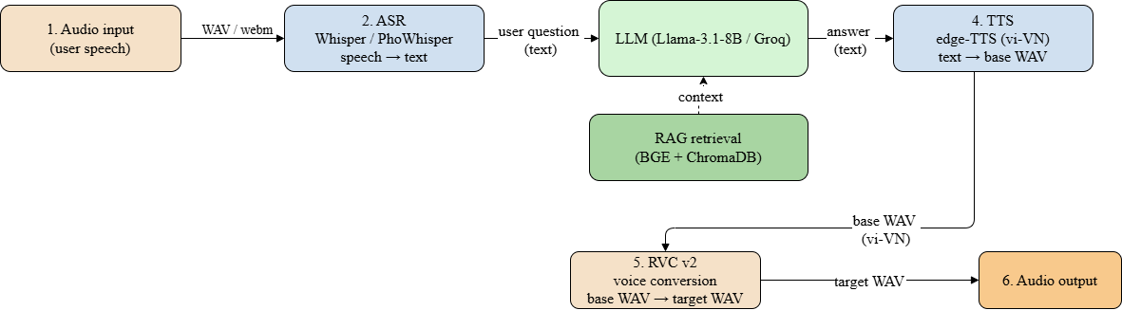
Figure 1: High-level abstract pipeline of the Legal Voice Assistant.

3.3 Software Architecture
The implementation architecture follows the existing client-server design and adds three internal modules under a new voice/ package, plus two new HTTP endpoints (/voice/transcribe and /voice/speak) registered alongside the existing /get RAG endpoint. RVC inference is offloaded to a Google Colab GPU instance over a cloudflared tunnel, isolating the fairseq + torch dependency stack from the Python 3.12 web service. All other modules of the original assistant (engine/rag_engine.py, database/database.py, build_db.py, the login flow) remain untouched, which keeps the architectural change strictly additive and low-risk.

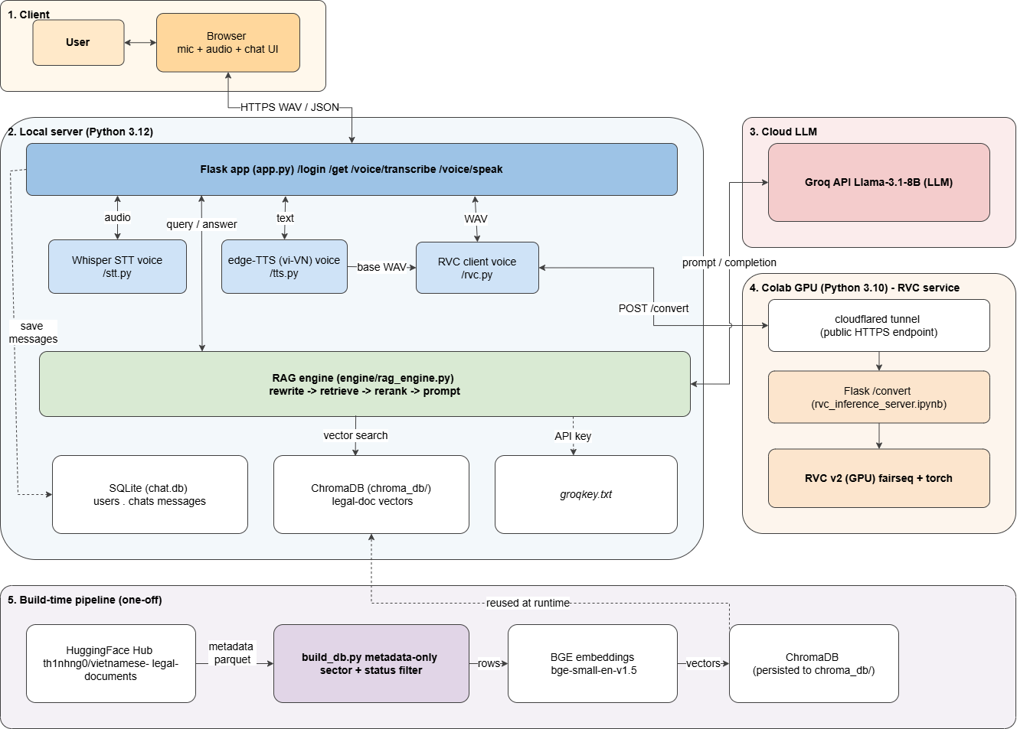
Figure 2: Software architecture of the Legal Voice Assistant.

3.3 Technology and Tools
Layer | Component | Technology
Application | Web framework & UI | Flask 3, Werkzeug, vanilla JS, MediaRecorder, HTML5 <audio>
AI core – LLM | Response generation | Meta Llama-3.1-8B-Instant served by Groq API
AI core – RAG | Retrieval grounding | LangChain, BGE-small-en-v1.5 embeddings, ChromaDB vector store
ASR | Speech recognition | OpenAI Whisper (small) or VinAI PhoWhisper-small
TTS | Neural speech synthesis | Microsoft edge-TTS — voice vi-VN-HoaiMyNeural / vi-VN-NamMinhNeural
RVC | Voice conversion | RVC v2  (HuBERT content encoder + HiFi-GAN vocoder + FAISS index), trained on Google Colab T4
Baseline | Zero-shot voice clone | Coqui XTTS-v2  (used only as evaluation baseline, not deployed)
Table 3: Technology stack of the integrated system.

4. Implementation Plan

4.1 Main Development Stages
The work is organised into five stages over twelve weeks:
- Stage 1 — Voice dataset preparation: record/clean ~15 min of target-speaker speech, slice into 3–8 s segments, normalise to 16 kHz mono.
- Stage 2 — RVC training on Colab: preprocess, F0 extraction with RMVPE, train RVC v2 for ~200 epochs, build the FAISS retrieval index, export .pth and .index.
- Stage 3 — Backend integration: implement voice/stt.py, voice/tts.py, voice/rvc.py, and voice/voice_engine.py; expose /voice/transcribe and /voice/speak.
- Stage 4 — Frontend integration: add MediaRecorder-based mic UI, voice-output toggle, and audio playback to the existing chat interface.
- Stage 5 — Evaluation & write-up: compute objective metrics, run a 20-participant MOS survey, compare against XTTS-v2, write the thesis.

4.2 Expected Schedule (12 weeks)
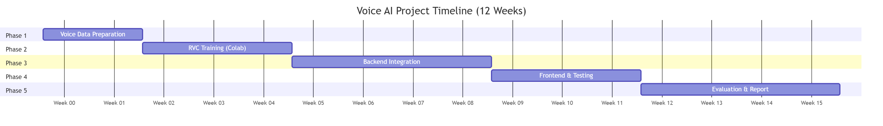
Figure 3: 12-week Gantt chart of the integration project.

4.3 Feasibility Assessment
The project is feasible. The RAG assistant is already implemented and serves as a stable substrate. Whisper, edge-TTS, and rvc-python are all open source and pip-installable. Google Colab provides free T4 GPU instances that are sufficient for training RVC v2 models of the planned size. The main technical risks are one end-to-end latency, addressed by chunked streaming and CPU-friendly model sizes, two acoustic quality of the training data, addressed by manual cleaning and a normalization prepossessing step, and three browser audio compatibility, addressed by transcoding all uploaded audio through ffmpeg + pydub before feeding it to Whisper.

5. Expected Results
The deliverable of this thesis are the following:
- An extended version of the existing rag-legal-assistant Flask application with new endpoints /voice/transcribe and /voice/speak, plus mic and audio-playback UI elements.
- A reproducible Google Colab notebook (colab/train_rvc.ipynb) that trains an RVC v2 voice model end to end, including data prepossessing, training, and index extraction.
- At least two trained RVC voice models (.pth + .index) covering one female and one male Vietnamese target speaker.
- A quantitative evaluation report comparing the TTS + RVC pipeline against XTTS-v2 on the same set of 30 Vietnamese legal answers.
- The full thesis manuscript and a short demonstration video.

6. Evaluation Plan
Evaluation distinguishes the four pipeline layers (ASR, LLM, TTS, RVC) and combines objective and subjective metrics. The fixed test set is 30 Vietnamese legal questions with expert-curated reference answers.

6.1 Per-component Metrics and Acceptance Criteria
Layer | Metric (unit) | Type | Threshold
ASR | Word Error Rate (%) | Objective | ≤ 15 % on Vietnamese legal queries
LLM + RAG | Faithfulness (manual, 5-point Likert) | Subjective | Mean ≥ 4.0 on 30 questions
Pipeline | End-to-end latency (s) | Objective | ≤ 4 s for a 25-word question (CPU + GPU tunnel)
RVC output | Signal-to-noise ratio (dB) | Objective | ≥ 20 dB
RVC output | MOS naturalness (1–5, n=20) | Subjective | Mean ≥ 3.8
RVC output | MOS speaker similarity (1–5, n=20) | Subjective | Mean ≥ 3.5
Table 4: Per-layer evaluation criteria with thresholds.

6.2 Metric Definitions and Threshold Rationale

6.2.1 Word Error Rate (WER).
WER is computed against a reference transcription as WER = (S + D + I) / N, where S, D, I are substitution, deletion, and insertion counts and N is the total number of reference words. A 15 % threshold matches the published WER of Whisper-small on Vietnamese FLEURS [5,6] and is an industry-accepted level for transcription that remains useful as RAG-input text.

6.2.2 End-to-end Latency.
Latency is the wall-clock time from microphone-stop to first audible byte of the answer in the browser. It is measured as the sum of four internal segments — t_ASR + t_LLM + t_TTS + t_RVC + t_HTTP — using Python time.perf_counter() bracketing inside Flask. The 4 s threshold is derived from Nielsen's response-time guidelines (4 s is the upper bound for users to feel they are 'in dialogue with the system').

6.2.3 Signal-to-Noise Ratio (SNR).
SNR (dB) measures how loud the speech signal is relative to the noise floor introduced by the RVC re-voicing step. It is computed as SNR = 10 · log10(P_signal / P_noise), where the signal power is the RMS of the foreground speech segments and the noise power is the RMS of the leading and trailing 200 ms of silence in the same WAV. SNR below ~15 dB sounds 'hissy' to listeners; ≥ 20 dB is the threshold for studio-quality television voice-over [14] and is therefore the acceptance level for our RVC output.

6.2.4 Mean Opinion Score (MOS).
Twenty native Vietnamese-speaking volunteers will rate naturalness and target-speaker similarity on a 5-point Likert scale (1 = bad, 5 = excellent), using the ITU-T P.808 protocol. Each volunteer rates 30 answer pairs (TTS + RVC vs XTTS-v2) presented blind and randomized. The 3.8 / 3.5 thresholds reflect the lowest acceptable subjective scores reported for production-grade Vietnamese TTS systems in [15].

6.3 Methods Used to Reduce Latency (RQ3)
The latency contribution of the thesis is not the choice of models — those are off-the-shelf — but the engineering techniques applied around them. Four techniques will be measured:
- T1 — Model-size selection. Whisper-tiny vs Whisper-small vs Whisper-medium are benchmark on the same 30-question test set; the smallest model that meets the 15 % WER threshold is deployed.
- T2 — Inference-server offloading. RVC inference is moved off the local Python 3.12 host onto a Colab T4 GPU exposed via a cloudflared tunnel; the saved time on RVC offsets the added network round-trip.
- T3 — Streaming TTS with overlap-aware RVC. edge-TTS streams the base WAV in chunks; chunks are forwarded to RVC as soon as they arrive, reducing the head-of-line blocking caused by full-utterance synthesis.
- T4 — Answer truncation for the spoken path. Long legal answers are abridged to ~150 words before TTS by a lightweight summariser running alongside the LLM; the full answer is still shown in the chat transcript. This trades verbosity for spoken latency.
For each technique the report will present a before/after latency table broken down per pipeline stage so that the contribution of each engineering choice is directly observable. Reduction of total latency below the 4 s acceptance bound, while maintaining the MOS thresholds in section 6.1, is the primary measurable outcome of contribution C3.

7. Expected Results
- An extended version of the rag-legal-assistant Flask application with /voice/transcribe and /voice/speak endpoints, plus mic and audio-playback UI elements.
- A reproducible Google Colab notebook that trains an RVC v2 voice model end-to-end (prepossessing, training, index extraction).
- A second Colab notebook that runs the RVC inference server and exposes it as a public HTTPS endpoint via cloudflared.
- At least two trained RVC voice models (.pth + .index) covering one female and one male Vietnamese speaker.
- A quantitative evaluation report covering all metrics in section 6.1 and the latency-reduction techniques in section 6.3.
- The full thesis manuscript and a short demonstration video.

8. References
[1] S. Ruan, J. O. Wobbrock, K. Liou, A. Ng, and J. Landay, "Comparing Speech and Keyboard Text Entry for Short Messages in Two Languages on Touchscreen Phones," Proc. ACM IMWUT (UbiComp), 2017.
[2] RVC Project, "Retrieval-based Voice Conversion (WebUI)," GitHub, 2023. https://github.com/RVC-Project/Retrieval-based-Voice-Conversion-WebUI
[3] P. Lewis et al., "Retrieval-Augmented Generation for Knowledge-Intensive NLP Tasks," arXiv:2005.11401, 2020.
[4] Y. Wang et al., "Tacotron: Towards End-to-End Speech Synthesis," arXiv:1703.10135, 2017.
[5] A. Radford et al., "Robust Speech Recognition via Large-Scale Weak Supervision" (Whisper), arXiv:2212.04356, 2022.
[6] T. H. Le et al., "PhoWhisper: Automatic Speech Recognition for Vietnamese," VinAI Research, 2024. https://github.com/VinAIResearch/PhoWhisper
[7] Coqui-AI, "XTTS-v2: Multilingual Zero-Shot Voice Cloning," 2023. https://huggingface.co/coqui/XTTS-v2
[8] Z. Qin et al., "OpenVoice: Versatile Instant Voice Cloning," arXiv:2312.01479, 2023.

